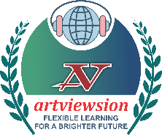**Artviewsion’s**

**All-Pakistan Digital Bilingual Speech Contest 2025**

**Consent Form for Participation**

**School/Individual Information**

* **School Name:** ___________________________________________
* **Branch:** ___________________________________________
* **City:** ___________________________________________
* **Email:** ___________________________________________
* **Coordinator’s Name:** ___________________________________________
* **Coordinator’s Mobile Phone:** ___________________________________________

**Participation Details**

* **Expected Number of Participants in English:** ____________________
* **Expected Number of Participants in Urdu:** ____________________

**Signature of Authorized School Representative/Individual:** ________________________

**Date:** ________________________